# PRACTICAL NO: 01

**AIM: Create MongoDB database, collection, insert records into collections, delete collections.**

1.Create New DB or Switch to Existing DB

**Syntax:** use DB_Name



2.Listing all the Databases

Syntax: show dbs

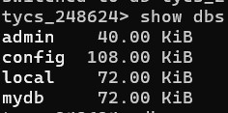

3. Check the DB currently in use

Syntax: db



4.Drop Database

**Syntax:**db.dropDatabase()



5.Create Collection

Creating a simple collection.

Syntax: db.createCollection(Name,Options)



6.Creating a Capped Collection

Syntax:db.createCollection(Name,{capped : true, size : sizeLimit , max : documentLimit })



7.Drop Collection

Syntax: db.collectionName.drop()



8.Insert Document into Collection

Inserting a single record

Syntax: db.collectionName.insertOne([{document1})

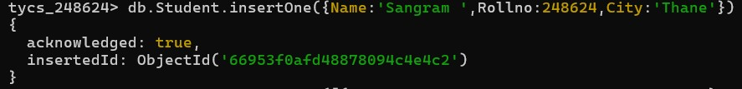

• Inserting multiple records

Syntax: Db.collectionName.insertMany([{document1},{document2},{ document3}….{ documentn}])4

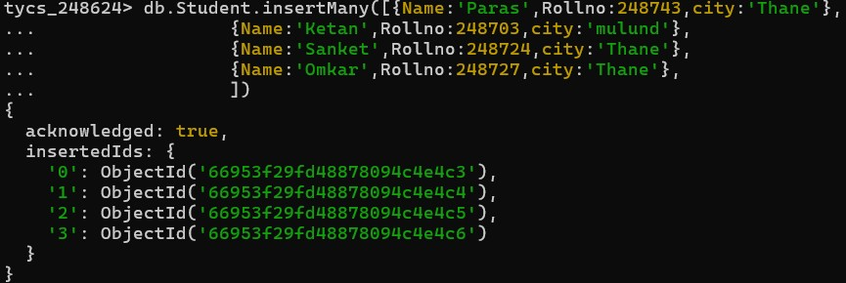

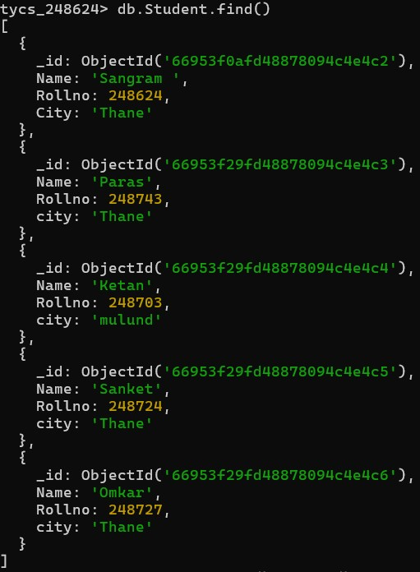9.Retrieve Document from a Collection

Syntax:db.collection.find()

Retrieval output

**Syntax**: collectionName.find().pretty()

